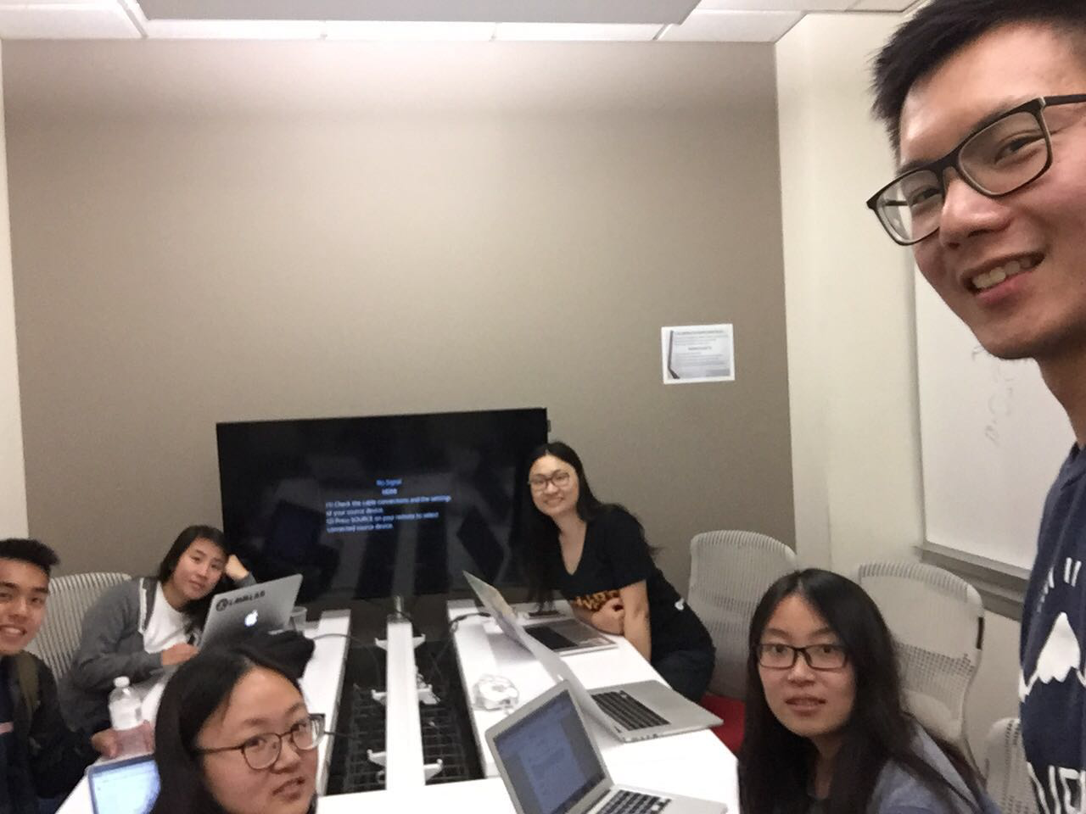

Allocated meeting time: April 21st, 6:00pm-7:00pm

Actual meeting time: April 21st, 6:00pm-7:00pm

Product owner: Professor Halfond, TAs, CPs

Scrum master: Gong Chen

Team members: Lingyi Li, Joann Lin, Peixuan Liu, Ryan To, Tuling Zhao

Scrum summary:

We were polishing our implementation code to make it more organized. We added some functionalities and were basically done with all the functionalities for the project. We merged all the functionality code together.

1. What have you accomplished since the last meeting?
2. Are there any obstacles in the way of meeting your goal?
3. What will you accomplish before the next meeting?

Gong Chen:

1. CollageServlet outputing message to front end when insufficient images found
2. None
3. Fixing collage size

Lingyi Li:

1. I was creating the task charts for this sprint.
2. None
3. I will create burndown charts for this sprint.

Joann Lin:

1. I merged the export and save features with the master branch and pushed them. I implemented back end functionality for delete collage.
2. None
3. I will work on testing the export and save features to make sure they are bug free. I will work on documentation

Peixuan Liu:

1. Added more tests for MySQLDriver and LogIn servlets
2. None
3. Continue working on adding tests for servlets

Ryan To:

1. I merged the different branches from gong and joann, implementing error and save collage feature to master.
2. None
3. I will finish writing the blackbox test cases for error, save collage feature and export.

Tuling Zhao:

1. Added “must choose one filter” functionality
2. None
3. Work on black box test for delete